1. **Introduction:**
2. **Description:**

This app automates the process of car rental system, by taking details of customer and his selection of cars and giving the bill after the car is relieved.

1. **Scope:**

This application handles user interfaces and databases and is limited to insert into, create and update the database records when a car is being rented or relieved and calculate the bill according to number of minutes it is used.

1. **Design:**
2. **User Interface:**

User interface consists of two forms in separate frames, one takes inputs to book a car and another to relieve a car.

The form which allows the user to book consists of

* Text Entry elements for Name, Driving License Number, Mobile Number and Emergency Mobile number.
* Radio Buttons to get Gender
* Spin Box widget, which allows values from 18 to 100 to get Age
* Combo Box widget to select from available car
* Submit button which runs the command

The form which allows the user to relieve car and fetch the bill consists of two combo boxes which have the values referring to the registration number of booked cars and licenced of user who booked them respectively.

1. **Database:**

A table ‘car’ to store the details of cars, which has attributes:

* ‘regNo,’ a string variable to store registration number of car which serves as a primary key
* ‘chasisNo,’ a string variable to store chassis number of car
* ‘manufacturer,’ a string variable to store manufacturer company
* ‘model,’ a string variable to store the model of car
* ‘no_of_seats,’ and integer variable to store number of seats in car

A table ‘person’ to store the details of the customer, which has attributes:

* ‘name,’ a string variable to store Name of the customer
* ‘age,’ an integer variable to store the Age of the customer
* ‘licence,’ a string variable to store the Driving Licence Number of the customer and serves as a primary key
* ‘mobile,’ an integer variable to store the Mobile Number of the customer
* ‘emergency_mobile’, an integer variable to store the Emergency contact’s Mobile number of the customer.

A table ‘rent’ which relates ‘car’ and ‘person’ tables to store rental details which has attributes:

* ‘carNO,’ a string variable to store the Registration Number of car
* ‘plicence,’ a string variable to store the Driving Licence of the customer
* ‘tookAt,’ an integer variable to store the time at which the car is taken for rent.

Car

Person

Rent

An Entity-Relationship Diagram denoting the attributes and relation between tables

1. **Algorithms:**

**Algorithm for Booking a Car:**

* User enters inputs and submits the form
* Application checks if the car is available and prompts user to select another car
* If the car is available, it searches for the user’s licence in ‘person’ table.
* If found, it asks user if an update is needed in his information, updates if he selects yes and skips if no.
* If not found, it inserts the user’s data into ‘person’ table.
* Finally, it inserts the car’s registration number, user’s driving licence number and current time into the ‘rent’ table.

**Algorithm to relieve car:**

* User enters the inputs and submits the form
* Application checks if the driving licence and car’s registration number entered by the user matches according to the ‘rent’ table
* If it does not match, the application prompts user to select a valid combination
* If it matches, the application reads the corresponding time taken and subtracts it from current time
* The result undergoes floor division by 60 to calculate number of minutes followed by multiplication with rent per minute to calculate bill
* The bill calculated is informed to the user.

1. **Project Source Code:**

The source code to the project is on the URL

1. **Results and Screenshots:**

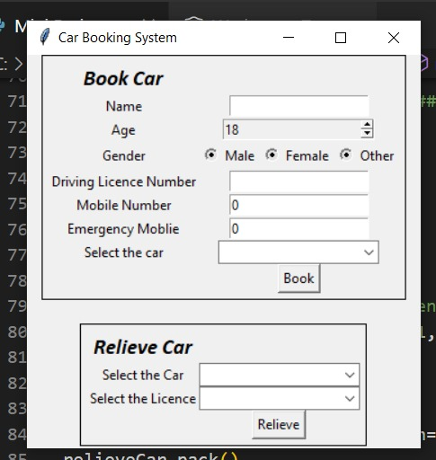

Figure 1: Initial Form

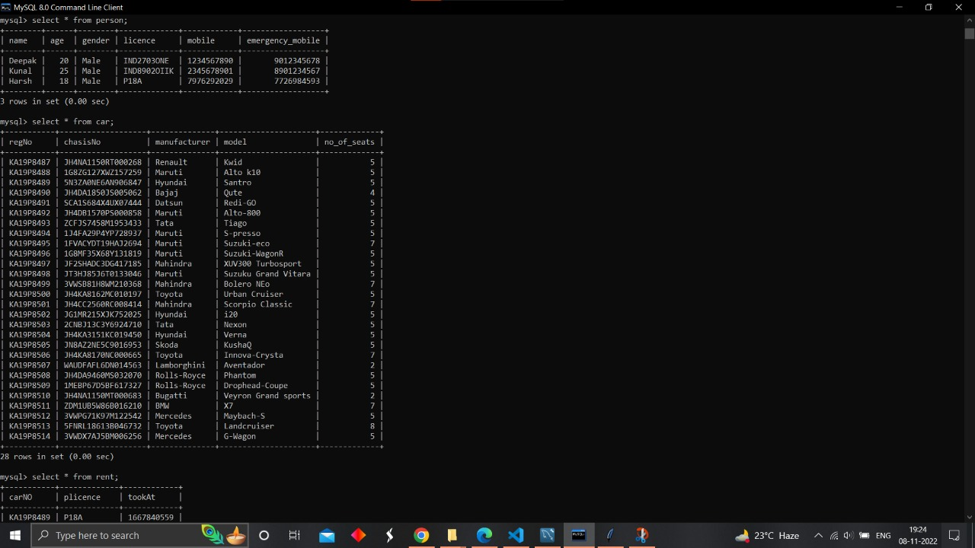

Figure 2: Databases used along with values

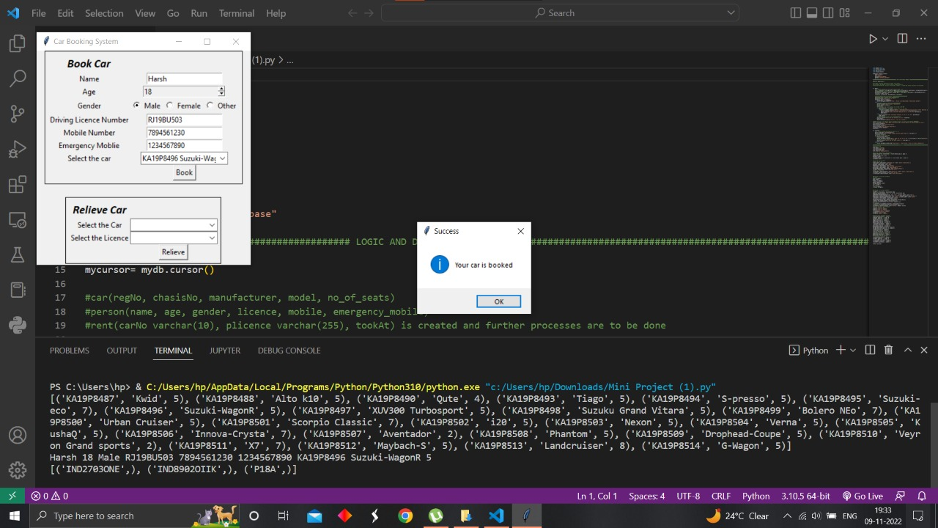

Figure 3:Message being displayed to the user that the car is booked

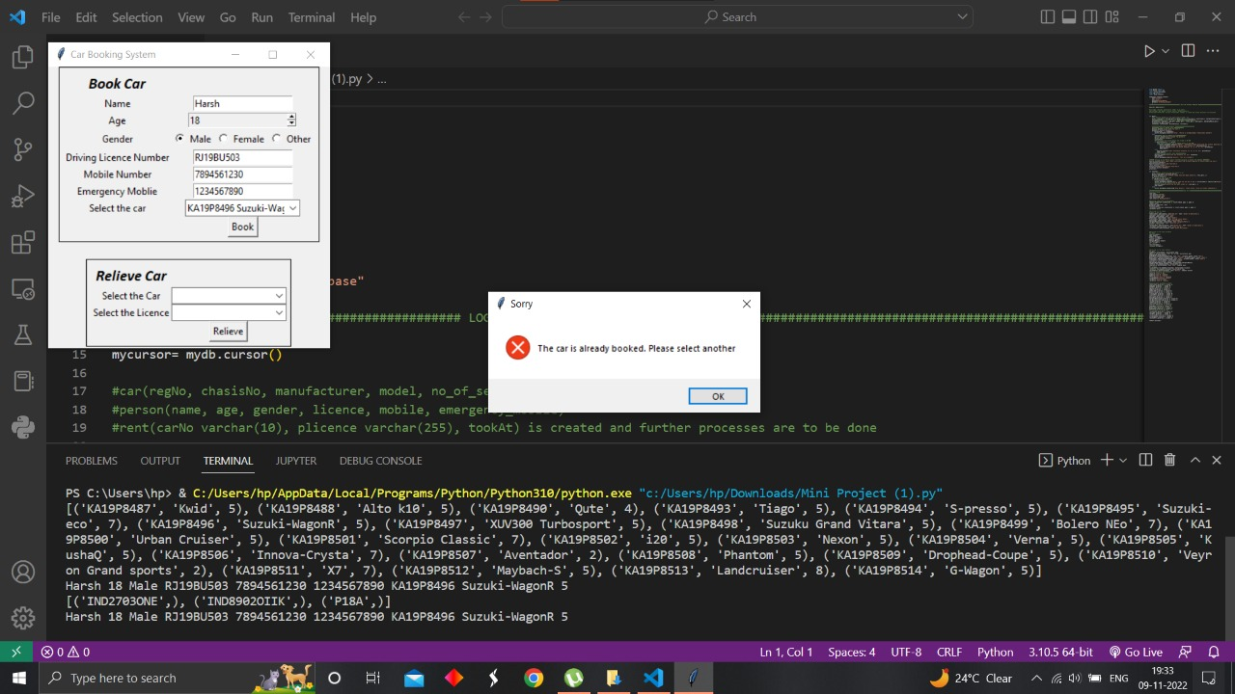

Figure 4: A message showing error message to the user that the car is already booked on repeated booking

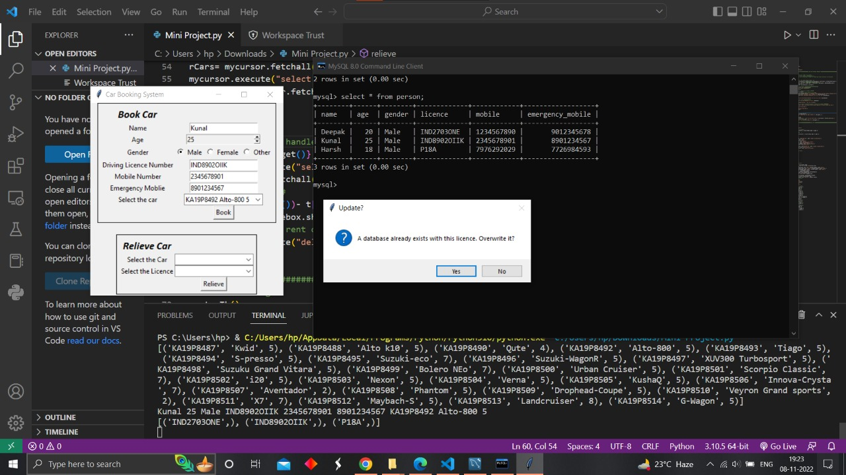

Figure 5: The Application asking user if it must update details after the form is filled again for same primary key

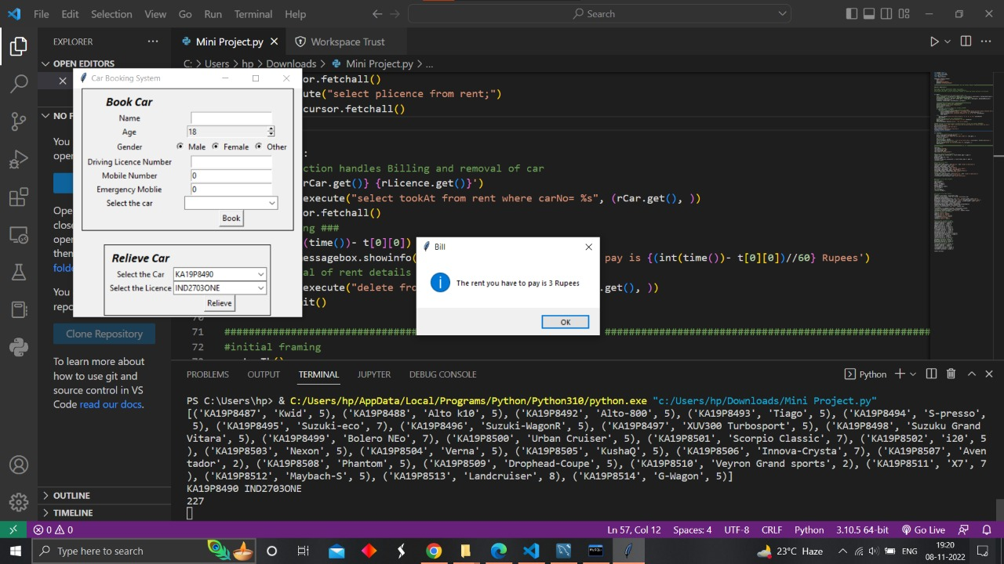

Figure 6: Informing user the calculated bill after relieving car

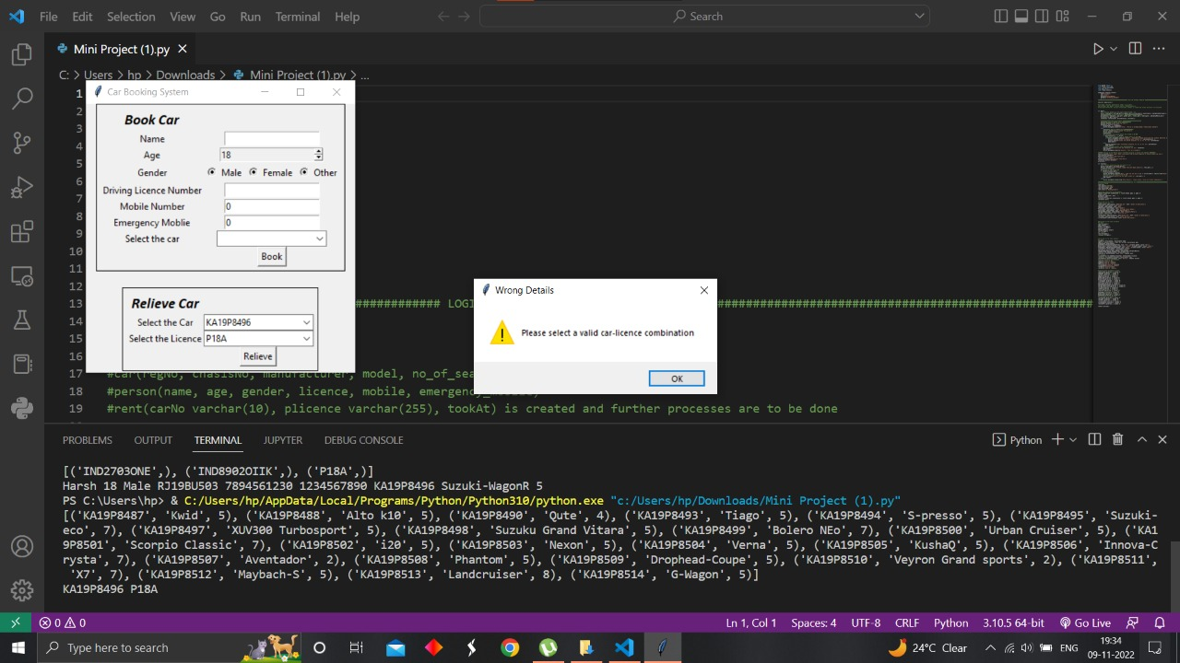

Figure 7: Prompt to user about wrong combination of vehicle and licence attributes

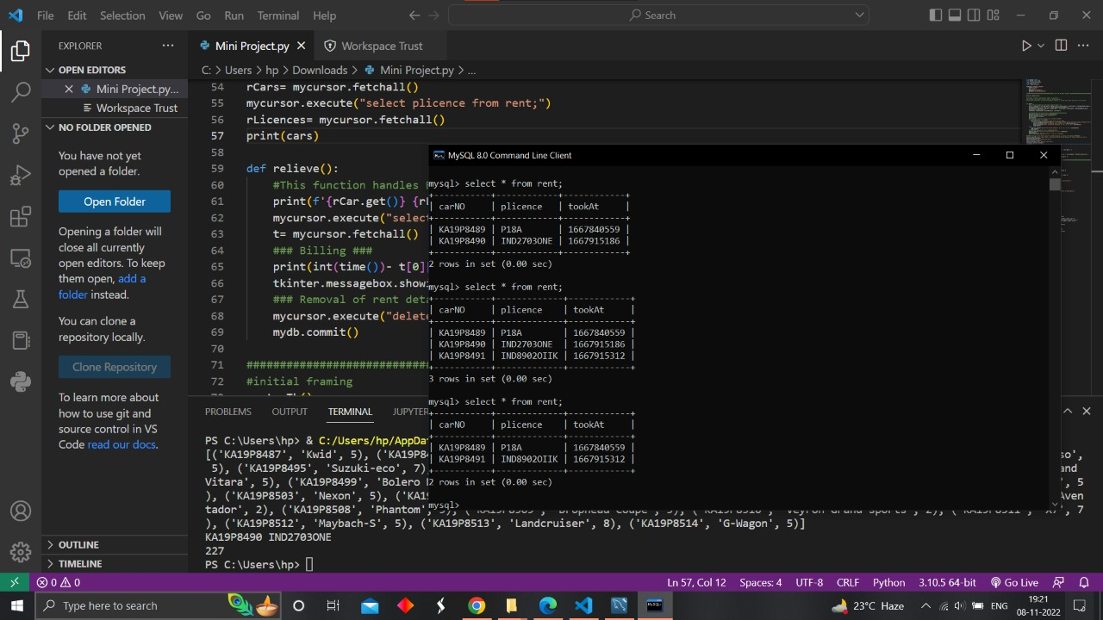

Figure 8: rent database before and after booking and relieving the car

1. **Contribution:**
2. **References:**

* ‘Python Time Module Reference’ from GeeksForGeeks on URL <https://www.geeksforgeeks.org/python-time-module/> which is used to find number of seconds the car is on rent to calculate bill.
* ‘Tkinter MessageBox Reference’ from Python Documentation on URL <https://docs.python.org/3/library/tkinter.messagebox.html#module-tkinter.messagebox> which is used to display information, warning and error messages on the interface.
* ‘Python Tkinter ComboBox Reference’ from GeeksForGeeks on URL <https://www.geeksforgeeks.org/combobox-widget-in-tkinter-python/> which is used to make user select the car when booking.
* ‘Python Tkinter ComboBox Tutorial’ from Python Tutorial on URL <https://www.pythontutorial.net/tkinter/tkinter-combobox/> which is used to limit the user to select only those car available (by changing state of widget to ‘readonly’).
* ‘Python Tkinter SpinBox Reference’ from GeeksForGeeks on URL <https://www.geeksforgeeks.org/python-tkinter-spinbox/> which is used to take the input for age to book car.
* ‘Python Tkinter SpinBox Reference’ from Python Documentation on URL <https://docs.python.org/3/library/tkinter.ttk.html#spinbox> which is used to restrict user from entering out of bound values.